**OUTREACH SCHOOLS EXAMINATION BOARD**

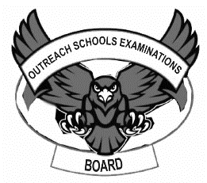 **END OF TERM II EXAMINATION 2024**

**TOP CLASS: (5 – 6 YEARS)**

**LEARNING AREA 3: HEALTH HABITS**

**My name is: ………………………………..………………………….**

**My School is: ……………………………..……….…………………..**

**I am in: ………………………………..…………………………………………..**

1. **Read and draw these body parts.**

|  |  |  |
| --- | --- | --- |
|  |  |  |
| mouth | nose | ears |
|  |  |  |
| teeth | tongue | eyes |

1. **Match the picture to a word for the sweet fruits.**

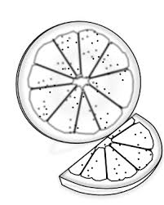 pawpaw

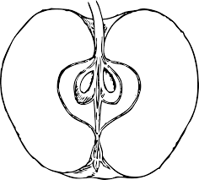

banana

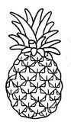

orange

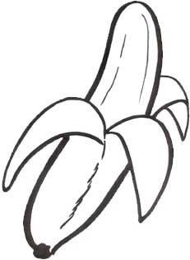

apple

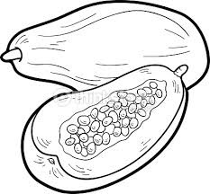

pineapple

1. **Match people who protect us and care for us.**

cook

mother cook ______________

father nurse ______________

doctor mother _____________

policeman father _____________

nurse doctor _____________

cook policeman ___________

1. **Read and draw things we use to clean our body.**

|  |  |  |
| --- | --- | --- |
| sponge | comb | water |
|  |  |  |
| brush | towel | soap |
|  |  |  |

**END**